**Tracking Changes in a Word Document**

*Anytime you want to view the document without the mark up just toggle the View from "Final: Show Markup" to "Final"*

1. Turn on Track Changes
   1. Click on the "Review" Menu item.
   2. Click on the Track Changes Icon.

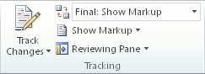

Changes to the document will be tracked and marked as you work with the document.

1. When you are through making changes. Simply save the document and the tracking information will be saved as well.
2. 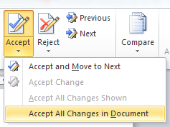To save a "Clean" Final copy of the document with all of the changes implemented, just click on the small triangle under the Accept Icon under the "Review" Menu item. Then choose "Accept All Changes in Document"
3. All changes are now implemented and you should now save the document with a new name that indicates it is the final version such as "Proposal_final.doc"